STEPS TO REGISTER FOR IHRD THARANG’23 - JOB FAIR

CANDIDATE REGISTRATION :

STEP 1 : Go to the IHRD Tharang’23 Website : <http://tharang.ihrd.ac.in>

STEP 2 : Navigate to the Job Fair Tab : as shown in the figure given below



STEP 3 : Select the “ COMPANY - LIST “ option in drop down menu which will redirect you to the page





STEP 4 : Click on any of the profiles to view the Full Eligibility of each companies

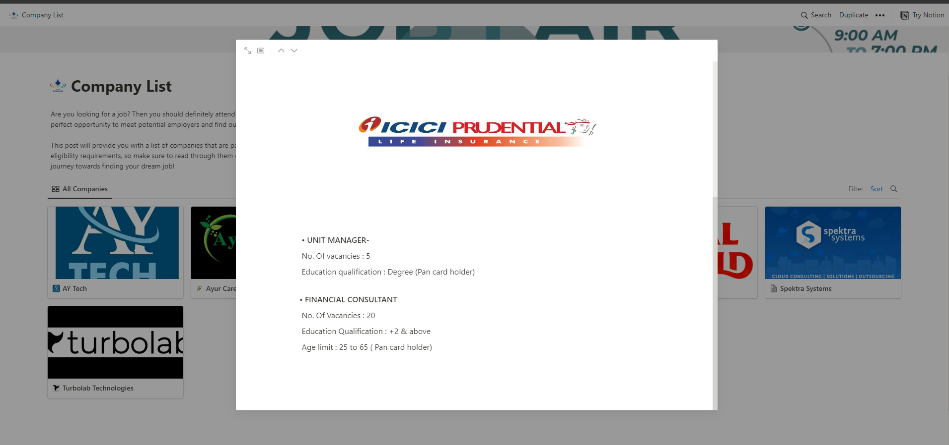

STEP 5 : Check all companies to find which all companies that you could apply for

STEP 6 : Go back to the Tharang’23 website and navigate to the Job Fair Tab



STEP 7 : Click on the “ Candidates option ” which will redirect you to a Guidelines Page



STEP 8 : Read the Guidelines Properly and scroll down to accept the terms and conditions

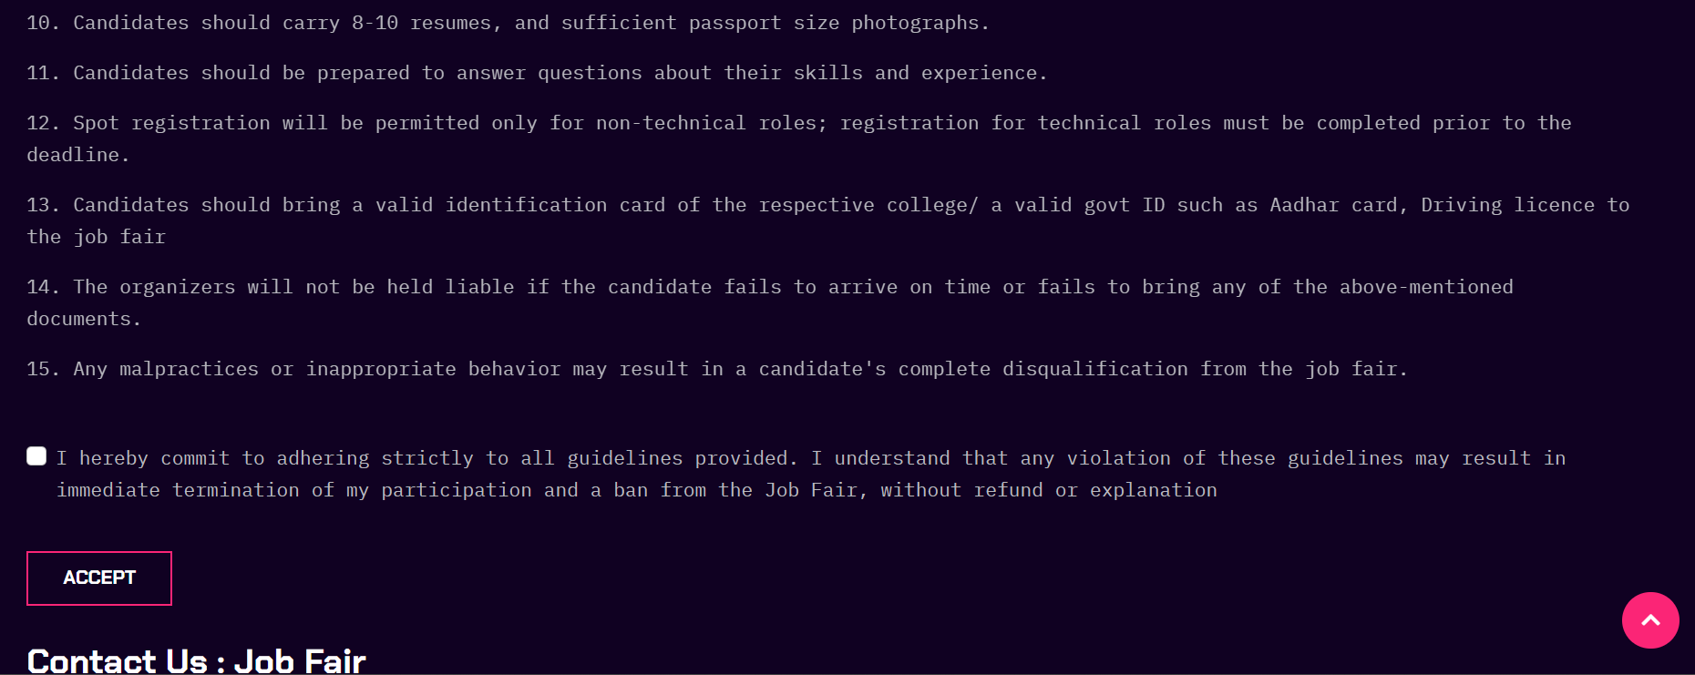

STEP 9: If you accept the terms and conditions click on the accept button which will redirect you to a google form

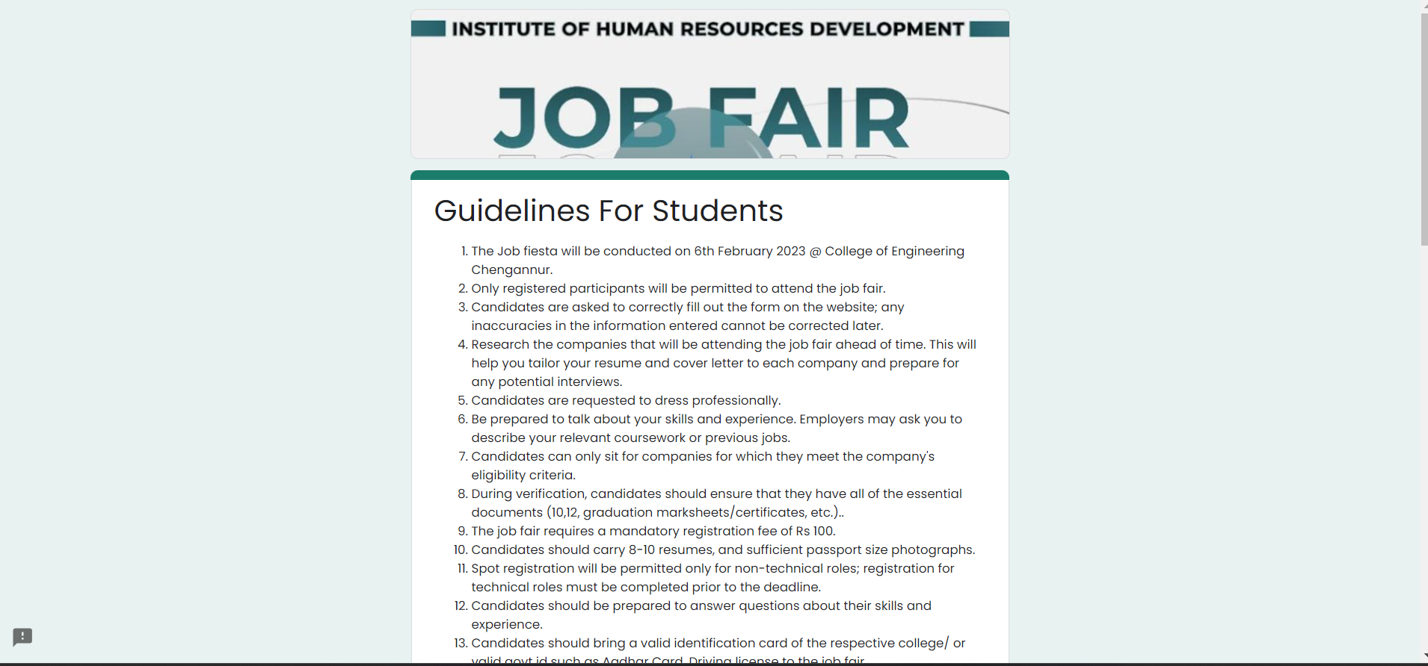

STEP 10 : Read the guidelines in the google form carefully

STEP 11 : Scroll Down to find options for the entering your email ID, and a link which will redirect you to the payment website

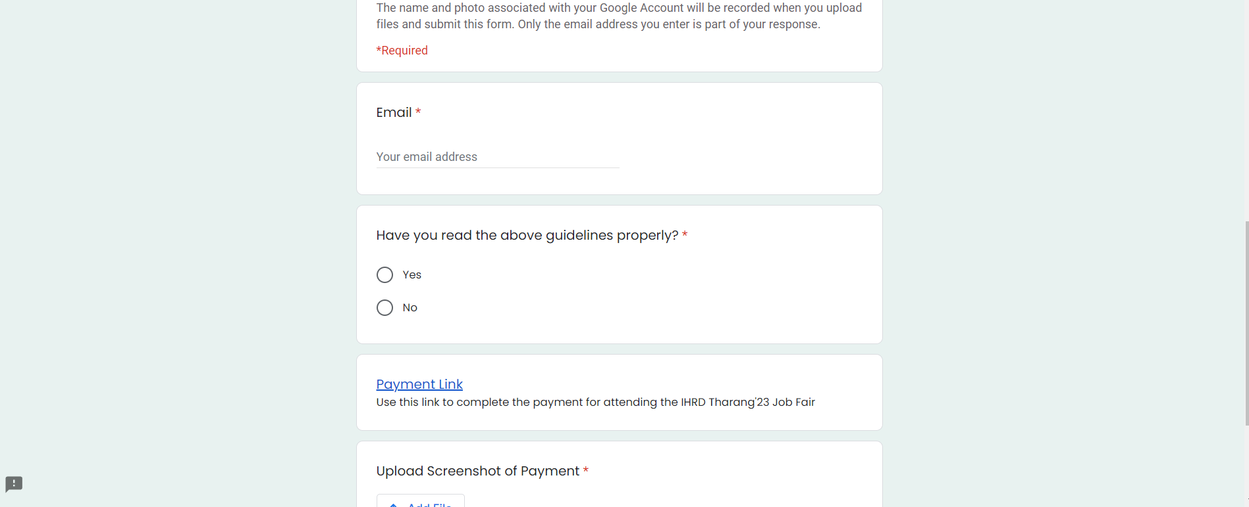

STEP 12 : Enter the necessary information in the google form and click the payment link

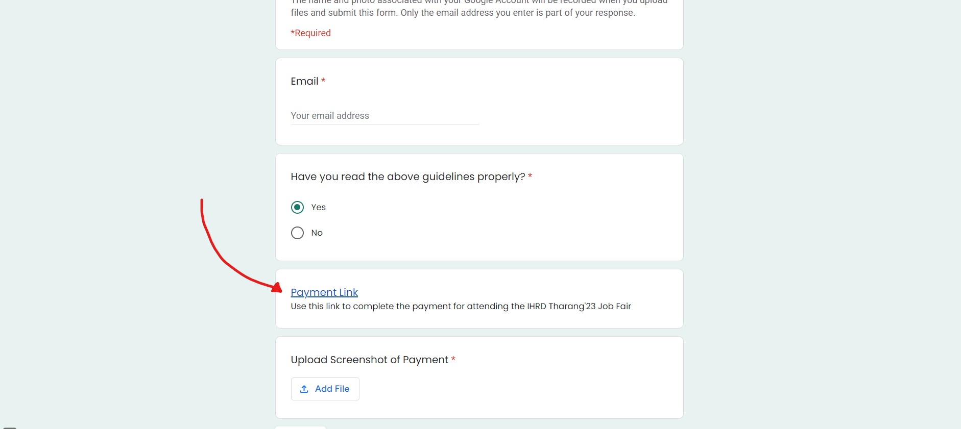

STEP 13 : On clicking the Payment link it will redirect to the yepdesk platform, where the payment is done



STEP 14 : Click on the “ BUY TICKETS” Button in the platform , as shown below

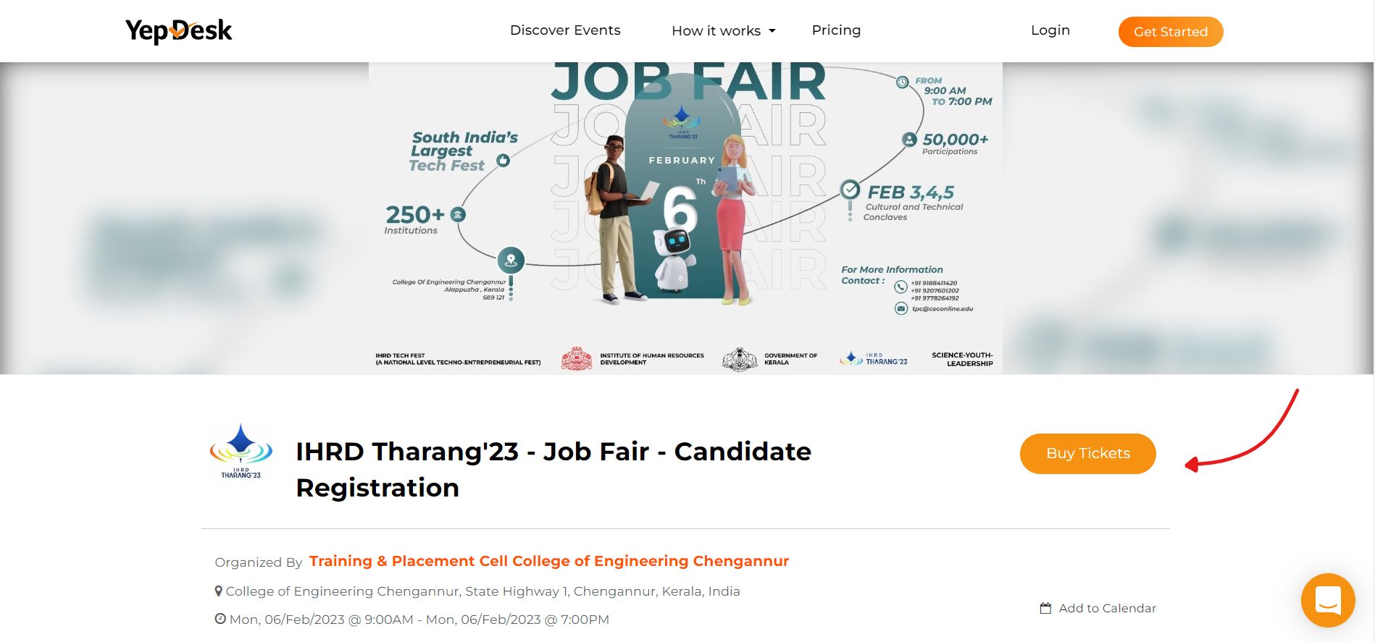

STEP 15 : You will be redirect to a page which allows you to choose the number of tickets for job fair

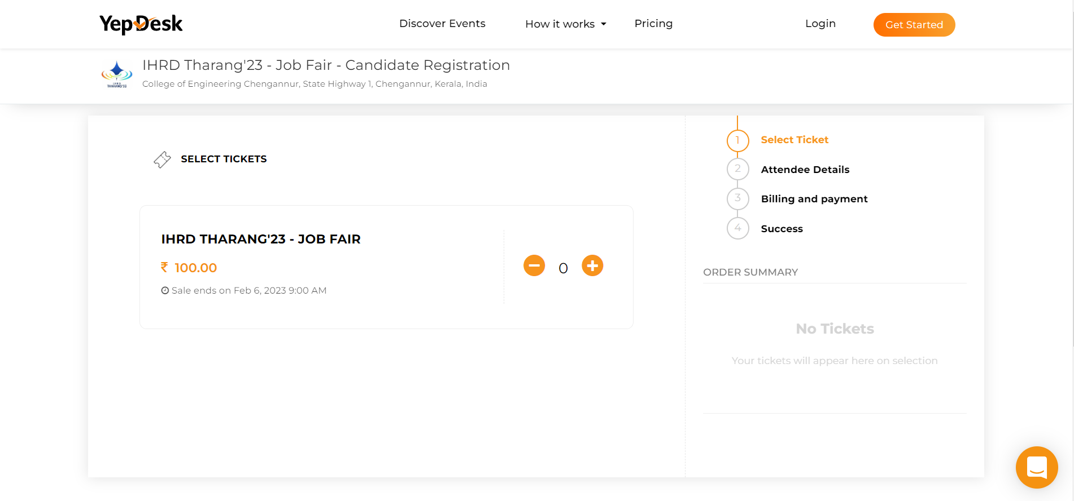

STEP 16 : Press on “+” button to increase the amount of tickets, the maximum number of tickets is one.

STEP 17 : Press on the place order button

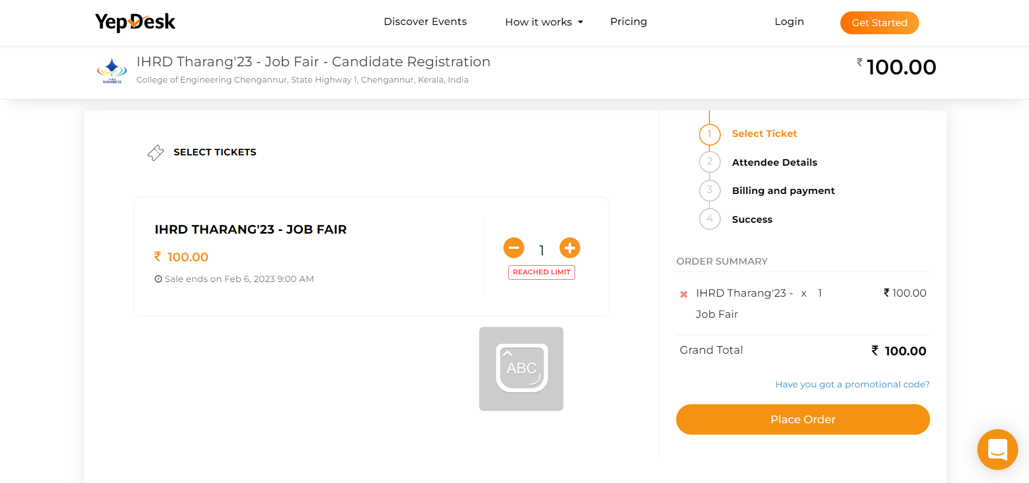

STEP 18 : Enter your details correctly in fields of Registrant Name, Email ID and Phone Number

STEP 19 : Scroll down to find the “ Agree” checkbox, click the box to proceed to next step

STEP 19 : Press on the “ Proceed to Billing ” button to proceed to the payment page

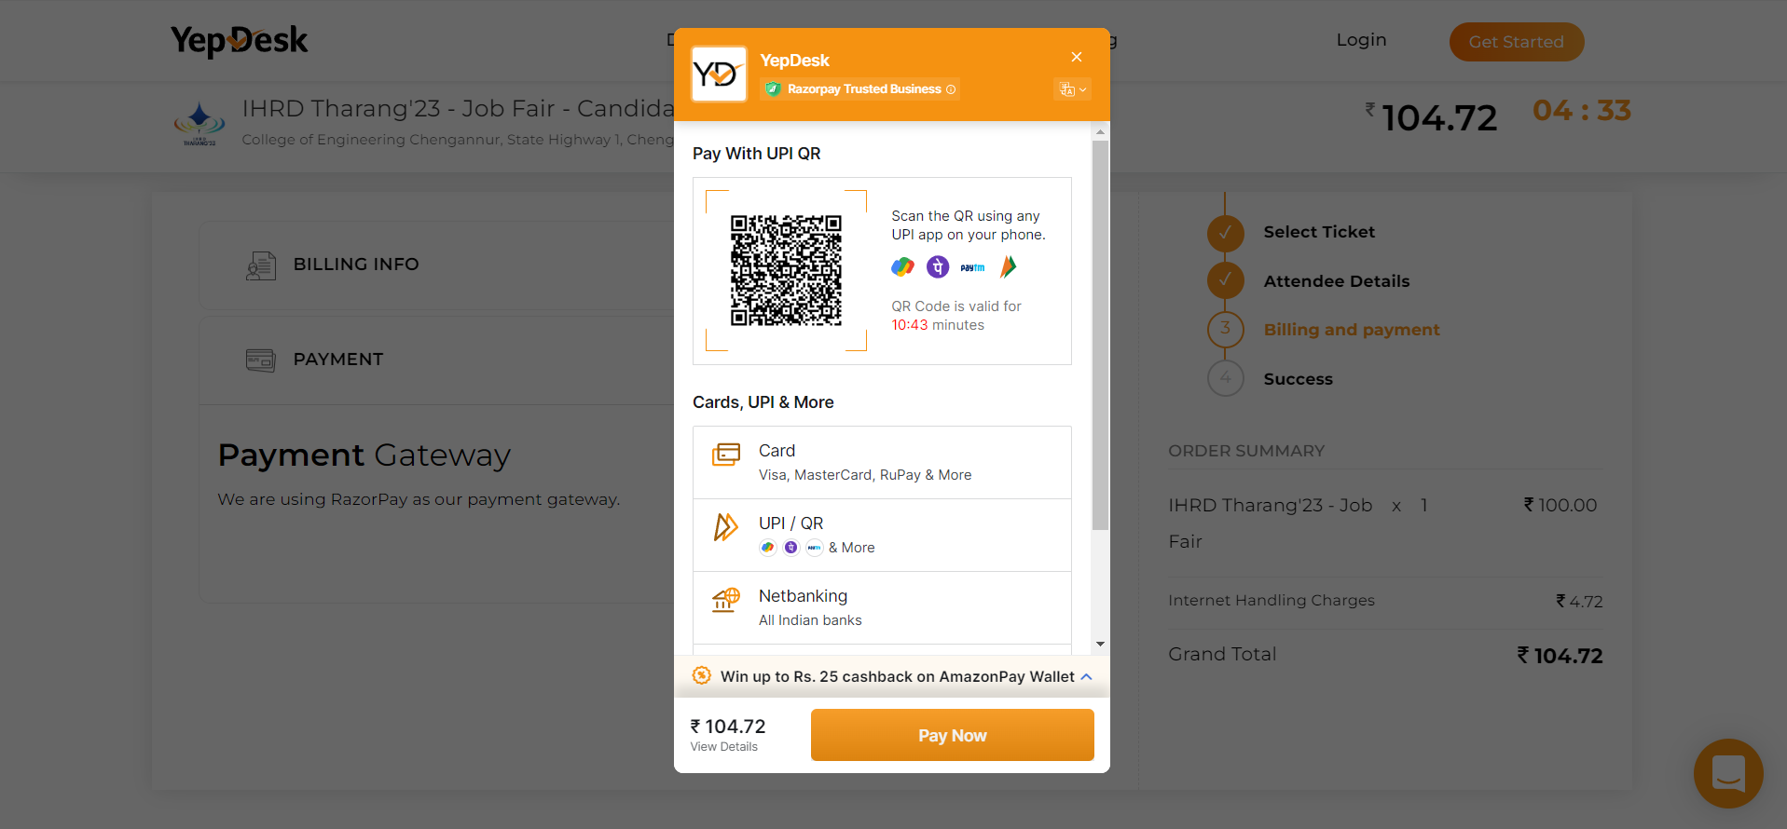

STEP 20 : Click on the Next Button, and select appropriate payment option to complete the payment procedures

STEP 21 : Take a screenshot of the completed payment procedure

STEP 20 : Come back to google from and upload the screenshot of the payment procedures, by clicking the add file

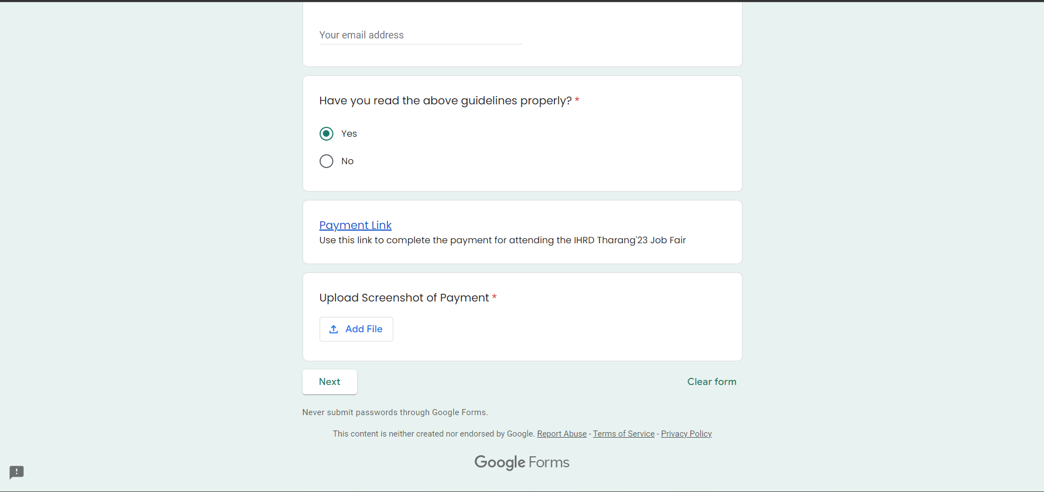

STEP 21 : Click the Next Button to go the next page

STEP 22 : Enter the details correctly in the Google Form

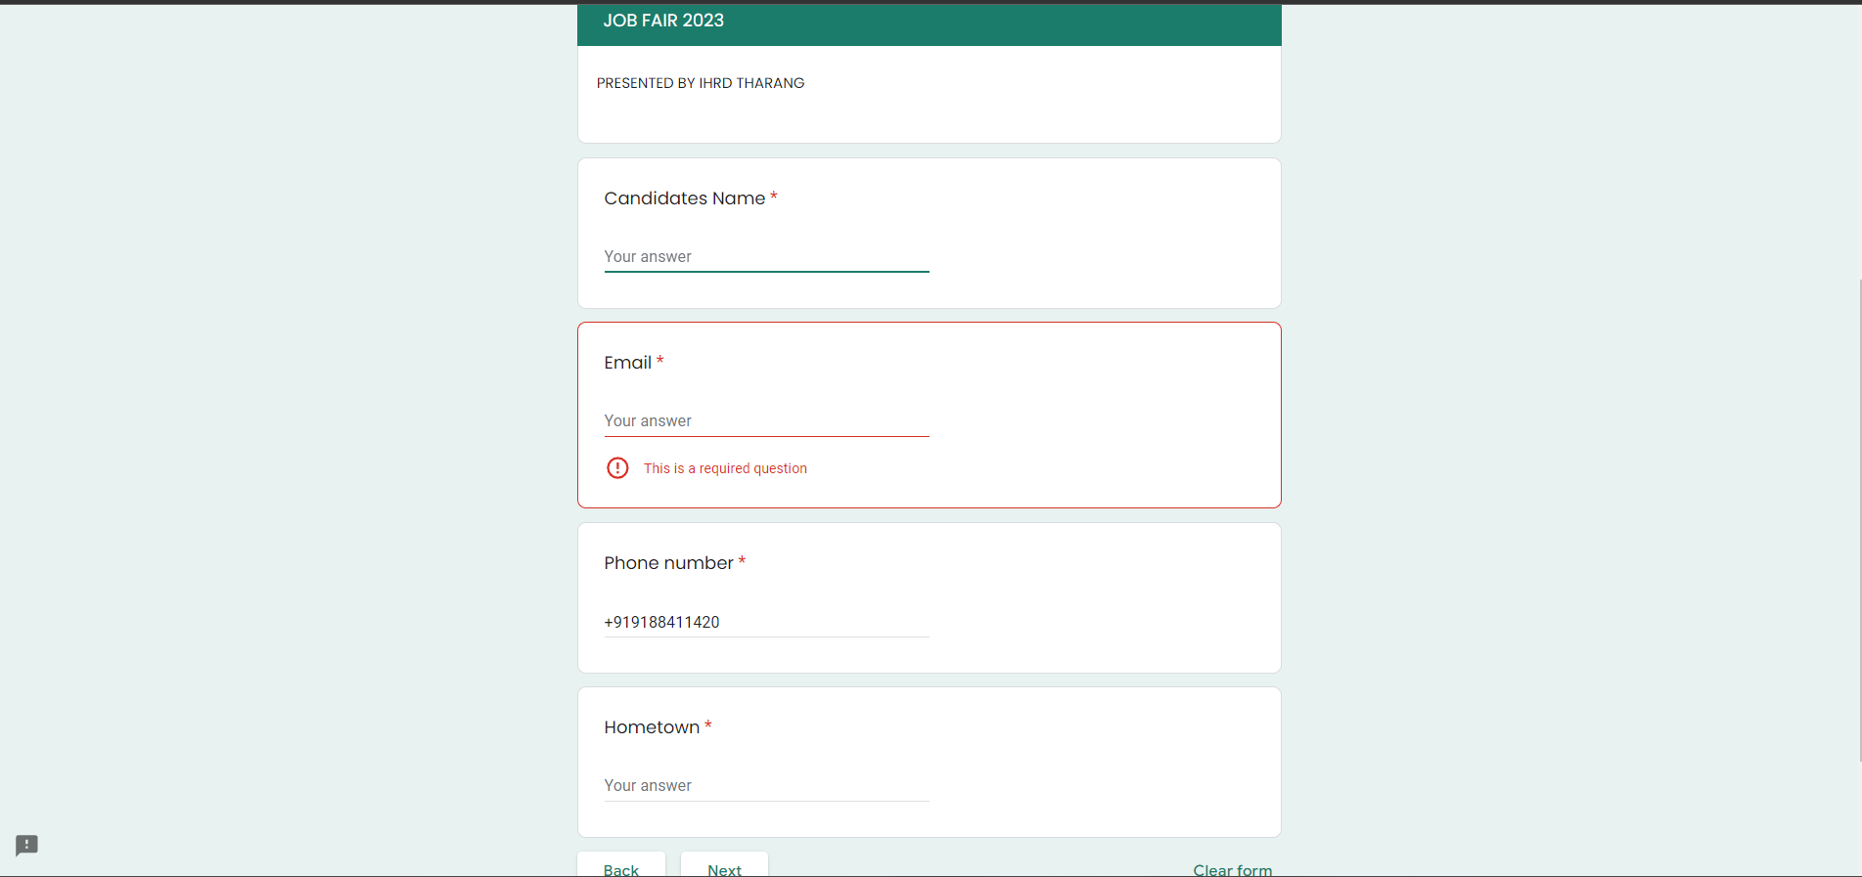

STEP 23 : Press the Next Button, to move to the next page, fill in the details correctly in the next page

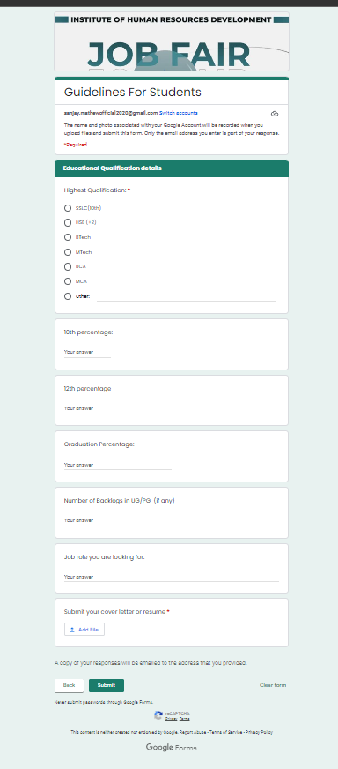

STEP 24: Upload your Resume and Click Next to Submit the Google Form

STEP 25 : Verify the details entered in the Google Form, using the copy of responses sent to your mail

After submitting the Google Form the registration process for the job fair has been completed.